SOFTWARE
TASK-2

BY
M.MAHESWARI
952319104023

INSTALL THE PYTHON IDL

Following this steps:

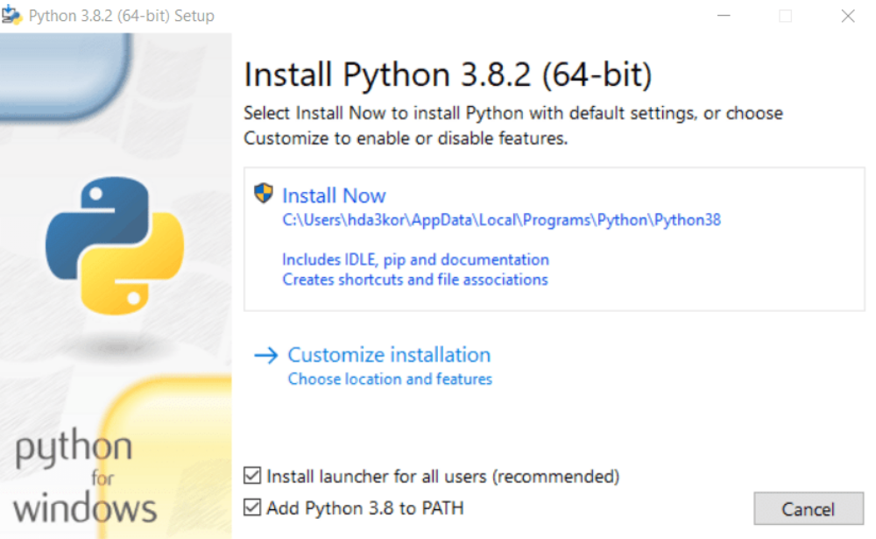

1.If you have 32-bit Windows, download this local copy of the Python 3.2 Windows installer. (Using the local copy avoids using up your student bandwidth quota. But if you are installing from off-campus, you can visit http://www.python.org/download/ and select the Python 3.2 Windows installer.)
1.For 64 bit Windows, use this Python 3.2 installer
2.Run the installer, installing it in C:\Program Files\Python32\ (vs. the default, which is C:\Python32 ). The other defaults are fine to use.

For 64-bit Windows 7, the file should be placed in C:\Program Files (x86)\Python32.

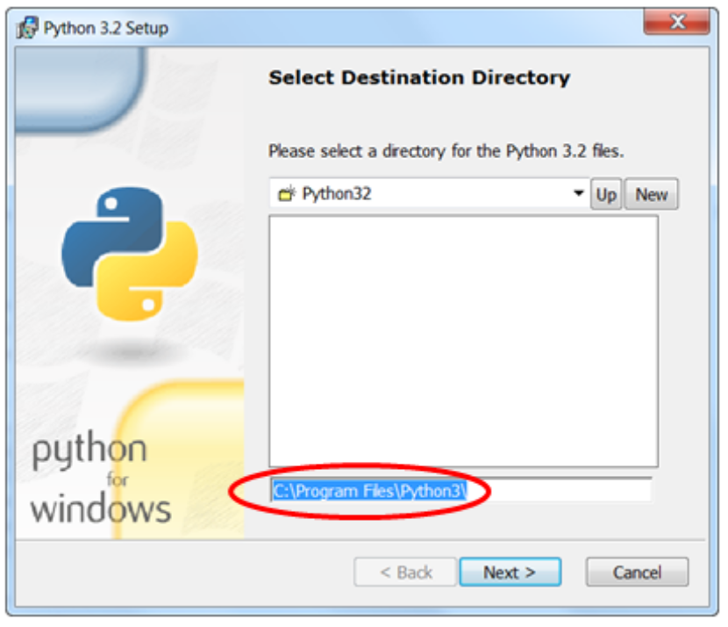

Change the directory that the Python development environment, IDLE, starts in when loading and saving files. (By default it looks for and saves files in the program directory.)
a. Log into your user account.
b. Click on Start → All Programs → Python 3.2
c. Right-click on IDLE (Python GUI) and choose Properties
d. Set the Start in: location to C:\EclipseWorkspaces\csse120

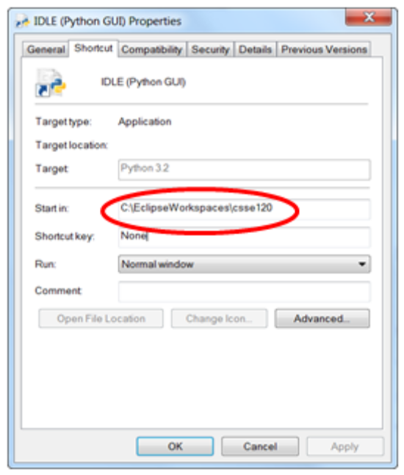

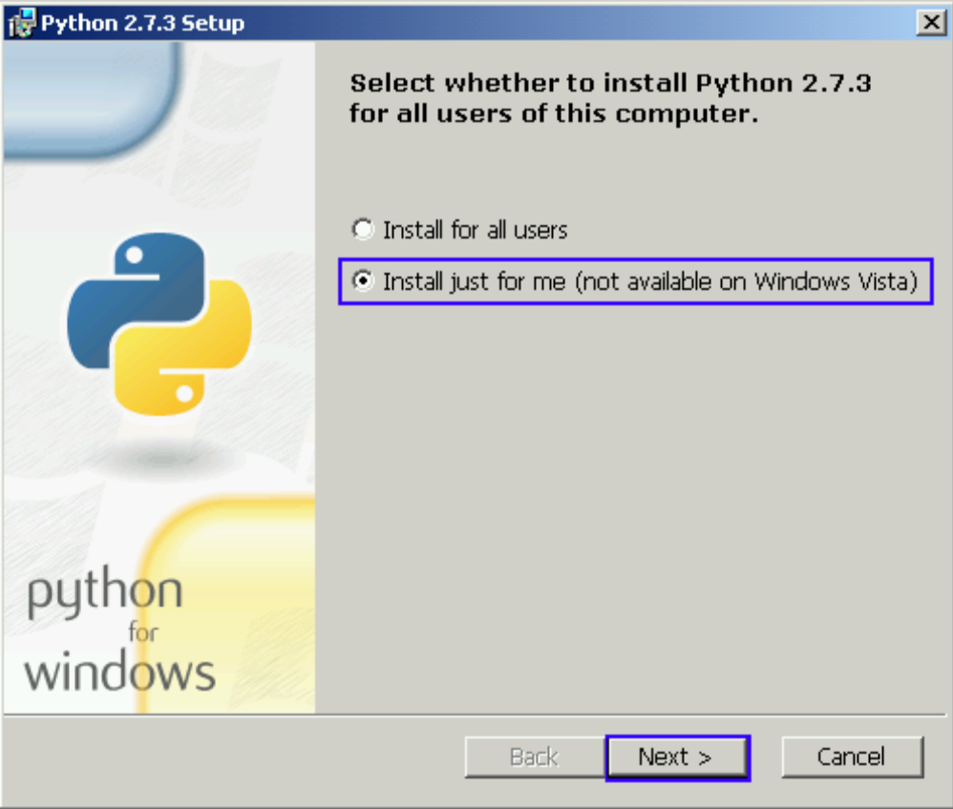

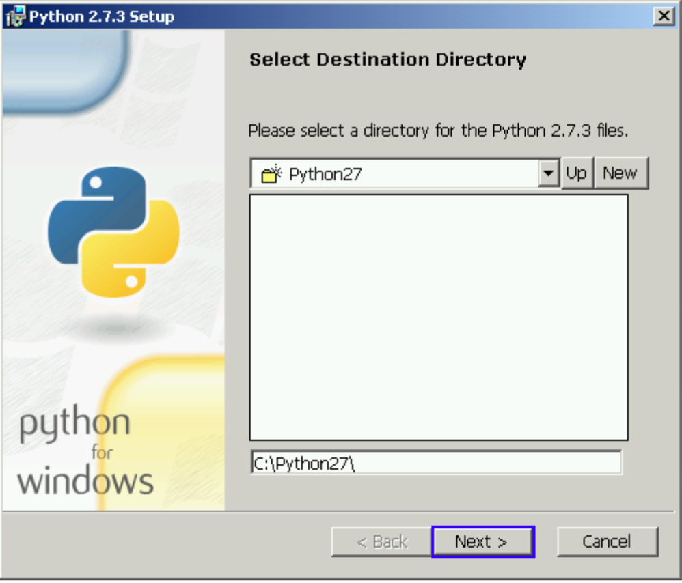

On the next screen, "Select Destination Directory" click "Next". This will install Python into "C:\Python27"
On the next screen, "Customize Python 2.7" click "Next". This will install Python with default settings.

On the next screen, wrap up the installation by clicking "Finish".

Processo de instalacao ebem simples. 1. Marque a opcao "Add Python to PATH" 2. Clique em "Install Now"
A tela abaixo será mostrada. Aguarde enquanto o instalador completa o processo de instalação.

